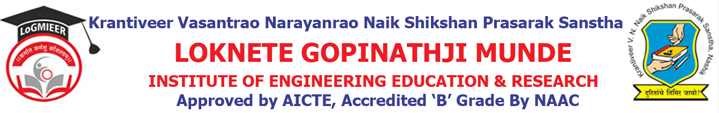
Department of AIML Engineering
ACADEMIC CALENDER-2023-24 SEM II
Sr. No. | Details of Activities | Weeks & Dates
1 | Course File & Practical File Checking | Week 1 | 20/12/2023 to 10/12/2023
2 | Commencement of Teaching:TE & BE | Week 1 | 28/07/2023 to 01/08/2023  _.
3 | Commencement of Teaching:SE | Week 2 Onwards | 01/01/2024
4 | Feedback Phase I | Week 3 | 19/02/2024 to 24/02/2024
5 | Unit Test I | Week 4 Onwards | 20//02/2024 to 14/02/2024
6 | Value Added Courses/Workshop | Week 03 to Week 13 | 12/08/2024 to 14/08/2024
7 | In-Sem Exam | Week 11 | 15/03/2024 to 30/03/2024
8 | Expert Talk | Week 03 to Week 13 | 01/04/2024 to 15/04/2024
9 | Industrial Visits | Week 12 | 08/03/2024
10 | Parent Meet | Week 15 | 29/03/2024
11 | Remedial Class | Week 16 | 24/04/2024 to 29/04/2023
12 | Conclusion of Teaching: TE | Week 16 | 30/04/2024 to 05/05/2024
13 | Feedback Phase II | Week 16 | 30/04/2024 to 05/05/2024
14 | Final TW Sub-mission | Week 16 | 08/05/2024
15 | Conclusion of Academic: TE& BE | Week 21 | 10/05/2024
16 | Conclusion of Academic: SE | Week 18 to Week 21 | 10/05/2024
17 | Theory Exam | Week 19 Onwards | 10/05/2024

Prof.A.S.Nalge Prof. N. V. Kapade
Academic Co-ordinator HOD

